**IOT MID SEMS**

**Terminologies-**

Sure, let's break down each term and concept:

1. **Embedded Systems**:

- Embedded systems are specialized computing systems that are designed to perform specific tasks or functions within a larger system.

- These systems typically consist of a combination of hardware and software components that are tightly integrated and optimized for efficiency.

- Embedded systems are commonly found in everyday devices such as smartphones, appliances, automobiles, medical devices, industrial machinery, and more.

2. **Not Necessarily Connected**:

- This refers to the fact that embedded systems may not always be connected to external networks or the internet.

- While some embedded systems may have connectivity features, such as Wi-Fi or Bluetooth, others may operate in isolation without the need for external communication.

3. **Sensor Networks**:

- Sensor networks are collections of sensor devices that are interconnected to gather and transmit data about their environment.

- These sensor devices can measure various physical parameters such as temperature, humidity, pressure, light, motion, and more.

- Sensor networks are commonly used in applications such as environmental monitoring, home automation, industrial control, healthcare, and smart cities.

4. **Cyber-Physical Systems (CPS)**:

- Cyber-physical systems integrate computational and physical components to monitor and control physical processes.

- CPS typically involve real-time interaction between physical systems and computer-based algorithms or control systems.

- Examples of CPS include smart grids, autonomous vehicles, medical monitoring systems, and industrial automation.

5. **Real-Time Systems**:

- Real-time systems are those that are subject to timing constraints, where the correctness of the system depends not only on the logical results of computations but also on the timing of those results.

- These systems must respond to stimuli from the environment within a specified time frame, known as the deadline.

- Real-time systems are crucial in applications such as avionics, automotive systems, process control, and multimedia systems.

6. **Pervasive/Ubiquitous Computing**:

- Pervasive or ubiquitous computing refers to the idea of seamlessly integrating computing capabilities into everyday objects and environments, making them capable of anytime, anywhere computing.

- The goal is to create environments where computing resources are pervasive and easily accessible, allowing users to interact with digital services and information seamlessly.

- Examples include wearable devices, smart homes, smart cities, and augmented reality systems.

These concepts collectively represent the diverse and interconnected aspects of modern computing systems, particularly in the context of the Internet of Things (IoT) and related technologies.

**What is IOT**

Certainly! Let's break down the key points:

1. **Definition of IoT**:

- The Internet of Things (IoT) is a network of physical devices, which can include a wide range of objects such as vehicles, home appliances, industrial machines, wearable devices, and more.

- These physical devices are embedded with various technologies, including electronics, software, sensors, and actuators.

- The devices are connected to the internet or to each other, enabling them to communicate and share data.

2. **Components of IoT Devices**:

- **Electronics**: This encompasses the hardware components that provide the computing power for the device.

- **Software**: The software component includes the programs or applications that run on the device, providing functionality and enabling communication.

- **Sensors**: IoT devices are equipped with sensors to capture data from the physical world. These sensors can measure things like temperature, humidity, light, motion, and more.

- **Actuators**: Actuators are components that allow the device to perform physical actions or manipulate the environment based on the data collected. For example, turning on a motor or adjusting a valve.

- **Connectivity**: This refers to the ability of IoT devices to connect to the internet or to other devices. Connectivity options can include Wi-Fi, Bluetooth, cellular networks, or other communication protocols.

3. **Functionality of IoT**:

- IoT devices are designed to connect, collect, and exchange data.

- Connecting to the internet allows them to communicate with centralized servers, cloud platforms, or other connected devices.

- Collecting data involves gathering information from the device's sensors about the surrounding environment or the device itself.

- Exchanging data implies sharing this collected information with other devices or systems, enabling informed decision-making or triggering actions.

4. **Core Concept - Connection to the Internet**:

- At its core, IoT is about connecting devices to the internet. This connectivity allows for remote monitoring, control, and automation of devices.

- By being online, IoT devices can access cloud services, receive updates, and contribute to a larger ecosystem of interconnected devices.

In summary, the Internet of Things is a network of physical objects embedded with technology that enables them to connect to the internet, communicate with each other, collect data, and perform actions based on that data. The goal is to create a more interconnected and intelligent world where devices can operate collaboratively to enhance efficiency, convenience, and decision-making.

**SELF DRIVE CAR**

Certainly! Let's break down how a self-driving car works based on the information provided:

1. **GPS (Global Positioning System)**:

- Signals from GPS satellites provide the car with its absolute position on the Earth's surface. However, GPS alone may not provide precise enough positioning for tasks like lane-keeping or navigation in dense urban environments.

2. **Tachometers, Altimeters, and Gyroscopes**:

- These sensors complement GPS data by providing additional information about the car's speed, altitude, and orientation. This helps improve the accuracy of the car's positioning and navigation.

3. **Radar Sensor**:

- Radar sensors are used to detect objects in the car's vicinity, including other vehicles, pedestrians, and obstacles. They emit radio waves and analyze the reflections to determine the distance, speed, and direction of these objects.

4. **Ultrasonic Sensors**:

- Ultrasonic sensors are typically used for close-range detection, such as when parking or maneuvering in tight spaces. They emit high-frequency sound waves and measure the time it takes for the waves to bounce back, allowing the car to detect nearby objects like curbs or other vehicles.

5. **Lidar (Light Detection and Ranging)**:

- Lidar sensors emit pulses of laser light and measure the time it takes for the light to bounce back from surrounding objects. This provides highly detailed 3D maps of the car's surroundings, allowing it to detect lane markings, road edges, and obstacles with high precision.

6. **Video Cameras**:

- Video cameras capture visual information from the car's surroundings, including traffic lights, road signs, other vehicles, pedestrians, and obstacles. Advanced image processing algorithms analyze this data to identify and track objects, read road signs, and interpret traffic signals.

7. **Central Computer**:

- All the information collected from GPS, sensors, and cameras is processed and analyzed by a central computer onboard the vehicle. This computer integrates data from multiple sensors, interprets the environment, and makes decisions about how to navigate safely. It controls the steering, acceleration, and braking systems based on the analyzed data and predefined rules or algorithms.

8. **Radar Sensors for Adaptive Cruise Control**:

- Radar sensors are also used for adaptive cruise control systems, which automatically adjust the car's speed to maintain a safe following distance from other vehicles. These sensors continuously monitor the position and speed of nearby vehicles to ensure smooth and safe driving.

In summary, a self-driving car combines data from GPS, radar, lidar, ultrasonic sensors, and video cameras to perceive its environment. This information is processed by a central computer, which controls the car's navigation and driving functions, ensuring safe and efficient operation on the road.

**SMART FACTORY**

1. **Innovation**:

- The connected factory aims to foster innovation in industrial settings by enabling employees, including managers and supervisors, to access data from anywhere. This facilitates real-time monitoring and decision-making.

2. **Commercial Innovation**:

- There's an expectation that much of the innovation happening in other sectors will also apply to industrial activities, potentially leading to new business opportunities and efficiencies.

3. **Connect Engineers with Machines (MEM)**:

- This involves applying predictive maintenance techniques to detect early signs of machinery degradation, helping to prevent production disruptions and optimize equipment performance.

4. **Efficiency**:

- Connecting information technology (IT) systems with operational technology (OT) systems helps bridge the gap between data centers and factory control systems. This facilitates better coordination and sharing of best practices.

5. **Link Information & Operational Technology**:

- By integrating IT and OT, manufacturers can identify and share best practices, as well as optimize asset utilization in real-time.

6. **Optimize Assets**:

- Real-time visibility into people, equipment, and inventory allows for dynamic scheduling and inventory management, improving overall operational efficiency.

7. **Industrial Ethernet**:

- Building a robust Industrial Ethernet infrastructure enables reliable communication between various systems and devices within the factory, including supervisory control and data acquisition (SCADA) systems and local area networks (LANs).

8. **Agility**:

- By connecting and collaborating externally with suppliers and distributors, manufacturers can create dynamic workflows and respond quickly to changing market demands.

9. **Connect & Collaborate Externally**:

- Extending connectivity beyond the factory walls enhances supply chain visibility and agility, enabling faster responses to customer needs and market trends.

10. **Risk**:

- Ensuring the security of physical and cyber assets is crucial to protect processes, personnel, and plans from cyber threats and sabotage.

11. **Secure Physical & Cyber Assets**:

- Implementing robust security measures, such as industrial Ethernet-based security systems, helps safeguard critical assets from cyber attacks and breaches.

12. **Maximize Uptime**:

- Designing rugged and resilient industrial networking infrastructure ensures continuous operation even in harsh environments, minimizing downtime and maximizing productivity.

In summary, implementing a connected factory involves leveraging technology to enhance innovation, efficiency, agility, and risk management while maximizing uptime and asset utilization. This requires integrating various systems, connecting with external partners, and ensuring robust security measures to protect against cyber threats.

**Smart Animal Example**

The concept of the "connected cow" involves the use of various IoT (Internet of Things) technologies to monitor and manage the health, behavior, and productivity of cows in dairy farming. Let's break down each component:

1. **Necklace by Connecterra**:

- Connecterra, a Dutch company, produces Fitbit-style necklaces equipped with sensors to monitor a cow's movement and feeding habits. These sensors can detect irregularities that may indicate health issues or the cow's reproductive cycle, optimizing the timing of insemination.

2. **Acid Monitor by Well Cow**:

- Well Cow, a British company, has developed a bolus inserted into the cow's rumen to monitor acidity levels. This helps detect digestive problems early, allowing for timely intervention to maintain the cow's health and productivity.

3. **Tail Movements Sensor by Moocall**:

- Moocall, an Irish company, offers a birthing sensor attached to the cow's tail. It detects tail movements associated with labor contractions, sending SMS alerts to farmers approximately one hour before calving, enabling timely assistance during the birthing process.

4. **Pedometer by Afimilk**:

- Afimilk, based in Israel, produces pedometers for cows. These devices track the cow's walking activity, as cows typically increase movement during their reproductive cycle (oestrus). The pedometer alerts farmers to the optimal time for insemination, maximizing the chances of successful reproduction.

5. **Udder Sensors**:

- Automatic milking systems, such as Lely's Astronaut, can be equipped with sensors to monitor milk quality and detect signs of mastitis, an udder infection. These sensors help maintain milk quality and ensure the health of the cow's udder, ultimately improving overall productivity.

Overall, the connected cow concept leverages IoT technologies to provide farmers with real-time data on various aspects of cow health, behavior, and productivity. By monitoring and managing these factors more effectively, farmers can optimize dairy farming operations, improve animal welfare, and enhance milk quality and production.

**Enablers**

Certainly! Let's explore how IoT (Internet of Things) enables various capabilities and their corresponding uses:

1. **Portability**:

- **Enables**: IoT devices can be designed to be compact and lightweight, allowing them to be easily carried or installed in different locations.

- **Uses**: Portable IoT devices are utilized in applications such as wearable health trackers, asset tracking in logistics, and environmental monitoring in remote areas.

2. **Miniaturization**:

- **Enables**: IoT technology allows for the miniaturization of components and systems, making it possible to integrate sensors, processors, and communication modules into small form factors.

- **Uses**: Miniaturized IoT devices find applications in smart home devices, industrial sensors, and healthcare implants where space constraints are critical.

3. **Low Power and Low Heat**:

- **Enables**: IoT devices can operate efficiently with minimal power consumption, reducing heat generation and prolonging battery life.

- **Uses**: Low-power IoT devices are suitable for applications such as remote sensing, smart agriculture, and IoT-enabled wearables, where long battery life is essential.

4. **Connectivity**:

- **Enables**: IoT devices can communicate with each other and with central systems over various wireless and wired networks, enabling data exchange and remote control.

- **Uses**: Connected IoT devices are deployed in smart cities, industrial automation, and vehicle telematics, facilitating real-time monitoring and control of systems and processes.

5. **Convergence**:

- **Enables**: IoT brings together disparate technologies and systems, integrating them into unified platforms for data aggregation and analysis.

- **Uses**: Converged IoT solutions are applied in smart buildings, energy management systems, and integrated healthcare platforms, optimizing resource utilization and improving operational efficiency.

6. **Divergence**:

- **Enables**: IoT enables the customization and diversification of solutions to meet specific requirements and address unique use cases.

- **Uses**: Divergent IoT applications include personalized healthcare solutions, customized smart home automation, and tailored industrial IoT solutions, catering to diverse user needs and preferences.

7. **Ecosystem**:

- **Enables**: IoT ecosystems comprise interconnected devices, platforms, and services that collaborate to deliver value-added solutions and services.

- **Uses**: IoT ecosystems foster collaboration among stakeholders in areas such as smart cities, agriculture, and supply chain management, driving innovation and creating new business opportunities.

In summary, IoT enables a wide range of capabilities such as portability, miniaturization, low power, connectivity, convergence, divergence, and ecosystem collaboration, each serving specific uses across various industries and applications. These capabilities contribute to the advancement of IoT technology and its pervasive integration into our daily lives and business operations.

**IOT Issues and Challenges**

The excerpt highlights several issues and challenges associated with the implementation of IoT (Internet of Things) devices, particularly in terms of security vulnerabilities and potential risks. Let's break down each point:

1. **Attack**:

- IoT devices can be susceptible to various types of attacks, including unauthorized access, manipulation, and exploitation of vulnerabilities.

- Attackers may seek to take control of IoT devices for malicious purposes, such as gaining access to sensitive information or disrupting services.

2. **Take Control**:

- Attackers may attempt to take control of IoT devices remotely, exploiting security weaknesses in their firmware, software, or communication protocols.

- For example, smart door locks and lighting systems may be vulnerable to unauthorized access, allowing attackers to control them remotely.

3. **Steal Information**:

- IoT devices often handle sensitive data, such as personal information, location data, or financial details.

- Attackers may exploit vulnerabilities in IoT devices to steal this information for identity theft, fraud, or other malicious activities.

4. **Disrupt Services**:

- Attackers may seek to disrupt IoT services or systems by exploiting vulnerabilities and causing malfunctions or outages.

- For example, malware-infested refrigerators or pacemakers could be manipulated to send spam or malfunction, disrupting their intended functions.

5. **Examples of Vulnerabilities**:

- The excerpt provides several examples of vulnerable IoT devices and systems, including smart door locks, refrigerators, infotainment systems in cars, pacemakers, insulin pumps, and personal fitness devices.

- These devices may have security weaknesses that could be exploited by attackers to gain unauthorized access, manipulate their functionality, or steal sensitive data.

6. **Remote Control and Manipulation**:

- Hacked IoT devices, such as vehicle control systems or insulin pumps, may allow attackers to remotely control their operations.

- This could pose serious risks to user safety and privacy, as demonstrated by the potential for remote control of vehicle brakes or manipulation of medical devices.

Overall, the excerpt underscores the importance of addressing security concerns in IoT devices and systems to mitigate the risks of unauthorized access, data breaches, and service disruptions. Effective security measures, such as encryption, authentication, and regular software updates, are essential to safeguard IoT devices and protect user privacy and safety.

CPUs → MCUs → Embedded Systems

Certainly! Let's break down CPUs, MCUs, and Embedded Systems with diagrams illustrating their components:

1. **Central Processing Unit (CPU)**:

**Diagram**:

```

+-----------------------+

| CPU |

| (Central |

| Processing Unit) |

+-----------------------+

| Control Unit |

| ALU |

| Registers |

+-----------------------+

```

**Components**:

- **Control Unit**: Responsible for controlling the flow of data and instructions within the CPU and coordinating operations.

- **Arithmetic Logic Unit (ALU)**: Performs arithmetic and logical operations, such as addition, subtraction, AND, OR, etc.

- **Registers**: High-speed storage units used to store data temporarily during processing.

2. **Microcontroller (MCU)**:

**Diagram**:

```

+-----------------------+

| MCU |

| (Microcontroller) |

+-----------------------+

| CPU Core |

| Memory |

| Input/Output (I/O) |

| Peripherals |

+-----------------------+

```

**Components**:

- **CPU Core**: Similar to a CPU but integrated into a single chip along with other components.

- **Memory**: Typically includes ROM (Read-Only Memory) for firmware, RAM (Random Access Memory) for data storage, and sometimes EEPROM (Electrically Erasable Programmable Read-Only Memory).

- **Input/Output (I/O)**: Interfaces for connecting external devices, such as sensors, actuators, displays, and communication modules.

- **Peripherals**: On-chip peripherals may include timers, counters, analog-to-digital converters (ADCs), digital-to-analog converters (DACs), UART (Universal Asynchronous Receiver-Transmitter), SPI (Serial Peripheral Interface), I2C (Inter-Integrated Circuit), etc.

3. **Embedded System**:

**Diagram**:

```

+----------------------------+

| Embedded System |

+----------------------------+

| Microcontroller (MCU) |

| Sensors and Actuators |

| Communication Modules |

| Power Supply |

+----------------------------+

```

**Components**:

- **Microcontroller (MCU)**: The core processing unit of the embedded system, responsible for executing tasks and interfacing with peripherals.

- **Sensors and Actuators**: Input devices (sensors) and output devices (actuators) used to interact with the external environment.

- **Communication Modules**: Interfaces for connecting to networks or other devices, enabling communication and data exchange.

- **Power Supply**: Provides electrical power to the embedded system, ensuring proper operation of all components.

In summary, CPUs are standalone processing units, MCUs integrate CPU, memory, I/O, and peripherals into a single chip, and embedded systems combine MCUs with sensors, actuators, communication modules, and power supplies to perform specific tasks in various applications.

**Automotive Embedded System eg- Self Drive car**

Certainly! Let's break down the components and features of Automotive Embedded Systems, as described in the provided text:

1. **Adaptive Cruise Control (ACC) Systems**:

- These systems use sensors to detect the distance between your vehicle and the one in front of you.

- If the distance becomes too short, the system can adjust the vehicle's throttle, apply brakes, or sound an alarm to maintain a safe following distance.

2. **Advanced Airbag Systems**:

- These systems are equipped with crash-severity sensors that determine the severity of a collision.

- Based on the severity, the system can inflate the airbags to an appropriate level, reducing the risk of injury in low-speed accidents.

3. **Tire Pressure Monitoring Systems (TPMS)**:

- TPMS continuously monitors the air pressure in the tires.

- If the pressure drops below a certain threshold, the system sends warning signals to alert the driver, helping to prevent tire blowouts and maintain optimal tire performance.

4. **Drive-by-Wire Systems**:

- These systems electronically sense pressure on the gas pedal and communicate with the engine to control acceleration.

- By eliminating mechanical linkages, drive-by-wire systems provide precise control over throttle response, improving fuel efficiency and performance.

5. **Telematics**:

- Vehicles equipped with telematics have wireless communication capabilities.

- Telematics features include navigation systems, remote diagnostics and alerts, and internet access, providing drivers with enhanced convenience and connectivity on the road.

Now, let's illustrate these components in a diagram:

```

+----------------------------------+

| Automotive Embedded |

| System |

+----------------------------------+

| Adaptive Cruise Control (ACC) |

| Advanced Airbag Systems |

| Tire Pressure Monitoring |

| Drive-by-Wire Systems |

| Telematics |

+----------------------------------+

```

In summary, Automotive Embedded Systems encompass various technologies and features designed to enhance safety, performance, and convenience in vehicles. From adaptive cruise control to advanced airbag systems and telematics capabilities, these systems play a crucial role in modern automotive technology, improving driving experiences and safety for motorists.

**Automotive embedded system**

Automotive Embedded Systems refer to the integration of electronic control units (ECUs), sensors, actuators, and software within vehicles to perform specific functions related to safety, performance, comfort, and convenience. These embedded systems are designed to enhance various aspects of automotive operation and functionality. Here's an explanation of Automotive Embedded Systems and their key components:

1. **Electronic Control Units (ECUs)**:

- ECUs are embedded computing devices responsible for controlling specific functions within the vehicle. They receive input from sensors, process data, and send commands to actuators to perform actions.

- Examples of ECUs include Engine Control Units (ECU), Transmission Control Units (TCU), Anti-lock Braking System (ABS) Control Units, Airbag Control Units, and more.

2. **Sensors**:

- Sensors are devices that detect changes in the vehicle's environment or operating conditions and convert them into electrical signals.

- Common sensors in automotive embedded systems include speed sensors, temperature sensors, pressure sensors, proximity sensors, and position sensors.

3. **Actuators**:

- Actuators are components that receive commands from ECUs and perform physical actions or adjustments in the vehicle.

- Examples of actuators include motors for adjusting seat positions, solenoids for controlling fuel injectors, valves for regulating fluid flow, and motors for adjusting mirrors or windows.

4. **Software**:

- Software plays a critical role in automotive embedded systems, controlling the behavior of ECUs, processing sensor data, and providing intelligent functionalities.

- Automotive software includes embedded operating systems, application software for specific functions (such as engine management or infotainment), and diagnostic software for maintenance and troubleshooting.

5. **Functions and Features**:

- Automotive embedded systems enable a wide range of functions and features aimed at improving vehicle safety, performance, comfort, and convenience.

- Examples include Anti-lock Braking Systems (ABS), Electronic Stability Control (ESC), Adaptive Cruise Control (ACC), Lane Departure Warning (LDW), Collision Avoidance Systems, Infotainment Systems, and more.

6. **Integration and Interconnectivity**:

- Automotive embedded systems are interconnected to facilitate communication and coordination between various components and subsystems within the vehicle.

- Interconnectivity allows for data sharing, real-time monitoring, and coordinated control, enabling intelligent and responsive vehicle behavior.

Overall, Automotive Embedded Systems represent the convergence of electronics, software, and mechanical components to create intelligent and capable vehicles that enhance safety, efficiency, and user experience on the road. These systems continue to evolve with advancements in technology, driving innovation in the automotive industry.

**General Purpose Processors**

Certainly! A General-Purpose Processor, often referred to as a microprocessor, is a programmable device designed to execute a wide range of tasks and applications. Here's a detailed explanation of its features and benefits:

1. **Features**:

- **Program Memory**: General-purpose processors come with built-in memory that stores the instructions (programs) to be executed. This memory is often referred to as program memory or instruction cache.

- **General Data Path with Large Register File**: These processors feature a data path that can handle various types of data and operations. They typically include a large register file to store temporary data during computation.

- **General Arithmetic Logic Unit (ALU)**: The ALU is a fundamental component of the processor responsible for performing arithmetic and logical operations on data. General-purpose processors have a versatile ALU capable of executing a wide range of operations.

2. **User Benefits**:

- **Low Time-to-Market and Non-Recurring Engineering (NRE) Costs**: General-purpose processors are mass-produced and widely available, resulting in lower time-to-market for products utilizing them. Additionally, the design and development costs, known as Non-Recurring Engineering (NRE) costs, are relatively low compared to custom-designed processors.

- **High Flexibility**: General-purpose processors offer high flexibility because they can execute a wide range of tasks and applications. This flexibility allows developers to use the same processor for different applications without significant modifications.

3. **Examples**:

- Examples of general-purpose processors include the Intel Core i7, AMD Ryzen 5, and other CPUs found in personal computers, laptops, servers, and consumer electronics.

In summary, general-purpose processors are versatile devices capable of executing various tasks and applications due to their programmable nature and flexible architecture. They offer benefits such as low time-to-market, high flexibility, and widespread availability, making them suitable for a wide range of applications in computing and electronics.

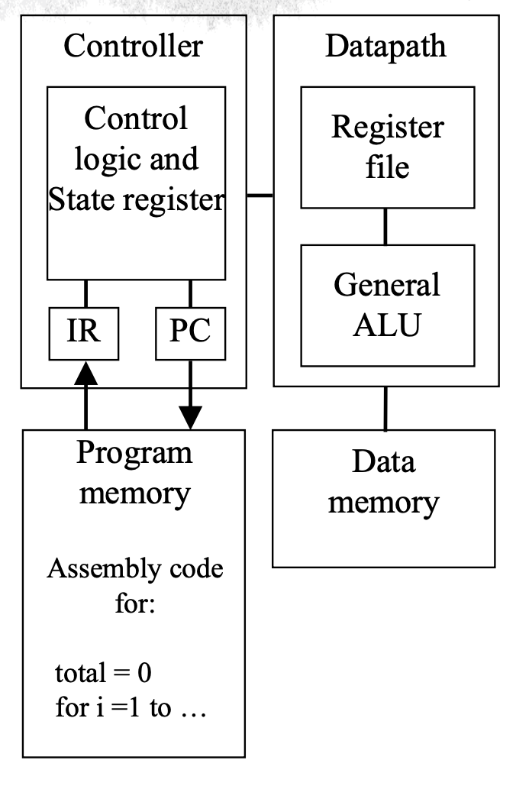

**Dedicated Processors**

Certainly! Let's delve into the concept of a Dedicated Processor, outlining its features and benefits:

1. **Definition**:

- A Dedicated Processor, also known as an Application-Specific Integrated Circuit (ASIC) or Application-Specific Standard Product (ASSP), is a digital circuit designed to perform a specific task or execute a particular program.

2. **Features**:

- **Contains Only Necessary Components**: Unlike general-purpose processors, dedicated processors are tailored to perform a specific function or execute a single program. They only include the components required to execute that particular task efficiently.

- **No Program Memory**: Dedicated processors do not typically include program memory like general-purpose processors. Instead, they are hardwired to execute a predefined set of instructions or algorithms.

3. **Benefits**:

- **Fast**: Because dedicated processors are optimized for a specific task, they can execute their designated function rapidly and efficiently. By eliminating unnecessary components and focusing solely on the required functionality, dedicated processors can achieve high performance.

- **Low Power**: Dedicated processors consume less power compared to general-purpose processors because they are designed to perform a specific function with minimal overhead. This efficiency is particularly advantageous in battery-powered devices or applications where power consumption is a critical factor.

- **Small Size**: Since dedicated processors contain only the components necessary for their designated task, they tend to have a smaller physical footprint compared to general-purpose processors. This compact size makes them suitable for integration into devices with space constraints or where miniaturization is important.

In summary, dedicated processors are specialized digital circuits designed for specific tasks or applications. They offer benefits such as high performance, low power consumption, and small size due to their focused design and optimized architecture. These processors play a crucial role in various industries, including telecommunications, automotive, aerospace, and consumer electronics, where efficiency and performance are paramount.

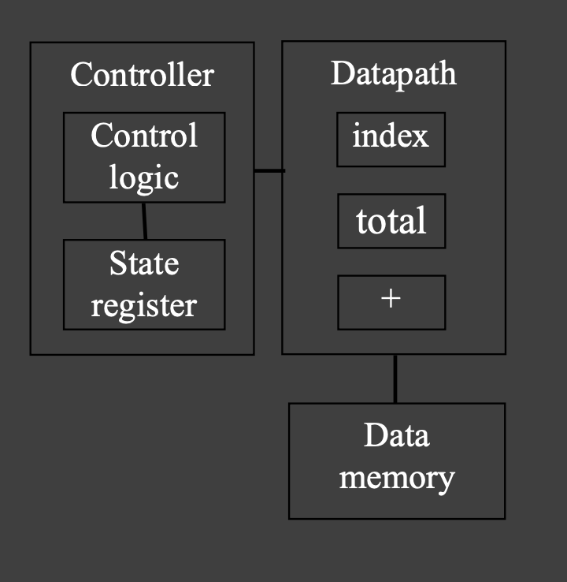

**ASIC- application -specific processors**

Certainly! Let's dive into the concept of an Application-Specific Processor (ASIC), also known as an Application-Specific Integrated Circuit, highlighting its features and benefits:

1. **Definition**:

- An Application-Specific Processor (ASIC) is a type of programmable processor optimized for a specific class of applications that share common characteristics. Unlike general-purpose processors, ASICs are designed to excel in particular tasks or applications rather than being versatile across a wide range of functions.

2. **Features**:

- **Program Memory**: ASICs include program memory to store instructions or algorithms specific to the targeted application. This allows the ASIC to execute the desired functions efficiently.

- **Optimized Data Path**: The data path within an ASIC is optimized to handle the specific data types and processing requirements of the targeted application. This optimization improves performance and efficiency.

- **Special Functional Units**: ASICs may include specialized functional units tailored to the needs of the targeted application. These units could include accelerators, custom hardware accelerators, or dedicated processing elements designed to perform specific tasks with high efficiency.

3. **Benefits**:

- **Some Flexibility**: While ASICs are optimized for specific applications, they still offer some level of flexibility compared to fully hardwired dedicated processors. This flexibility allows for minor modifications or adjustments to the design to accommodate variations within the targeted application class.

- **Good Performance**: ASICs deliver excellent performance for their targeted applications due to their optimized architecture and specialized design. By focusing on specific tasks or applications, ASICs can achieve high levels of performance and efficiency.

- **Size and Power Efficiency**: ASICs are typically designed to be compact and power-efficient, making them suitable for integration into various devices and systems. Their specialized architecture and optimized data paths contribute to reduced power consumption and smaller physical footprints.

- **Reusable**: In some cases, ASIC designs may be reusable for similar applications within the same class. This reusability can lead to cost savings and faster time-to-market for subsequent projects or product iterations.

In summary, Application-Specific Processors (ASICs) are programmable processors optimized for specific classes of applications. They offer benefits such as flexibility, high performance, size and power efficiency, and reusability within their targeted application domain. ASICs play a crucial role in various industries, including telecommunications, automotive, aerospace, and consumer electronics, where specialized processing capabilities are required to meet specific application requirements.

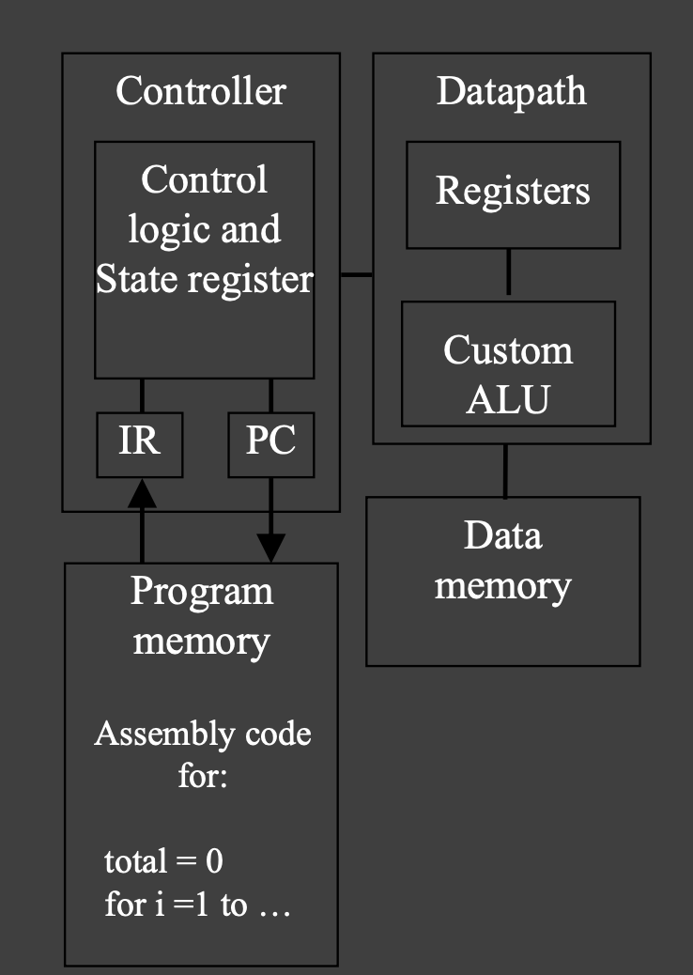

**Functions of Embedded System**

Certainly! Let's explore the functions of embedded systems in detail:

1. **Closed-Loop Control System**:

- **Function**: Embedded systems are often used to implement closed-loop control systems, where they continuously monitor a process or system's parameters (such as temperature, speed, direction, etc.) using sensors.

- **Operation**: Based on the measured parameters, the embedded system adjusts the system's outputs (such as motor speed, valve position, etc.) to maintain the desired set point or target value.

- **Example**: In a thermostat-controlled heating system, an embedded system monitors the room temperature using a temperature sensor. If the temperature deviates from the desired set point, the embedded system activates the heating or cooling system to adjust the temperature accordingly.

2. **Sequencing**:

- **Function**: Embedded systems can sequence through different stages or tasks based on environmental conditions or system states.

- **Operation**: These systems use programmed logic to transition between different operational modes or execute tasks in a predefined sequence.

- **Example**: In a washing machine, an embedded system controls the sequencing of operations such as filling water, agitating the clothes, rinsing, and draining based on the selected wash cycle and sensor inputs (e.g., water level, timer).

3. **Signal Processing**:

- **Function**: Embedded systems are capable of processing analog or digital signals to extract relevant information or remove noise.

- **Operation**: Signal processing algorithms implemented within embedded systems filter, amplify, or analyze signals to detect desired features or patterns.

- **Example**: In an audio system, embedded signal processing algorithms may remove background noise, equalize the audio frequency response, or apply audio effects such as reverb or echo.

4. **Communications and Networking**:

- **Function**: Embedded systems facilitate reliable and efficient communication and networking between devices, systems, or users.

- **Operation**: These systems implement communication protocols and networking standards to exchange information, commands, or data packets.

- **Example**: In a smart home automation system, embedded devices communicate wirelessly or over a network to control lights, thermostats, security cameras, and other connected devices. They may use protocols such as Wi-Fi, Bluetooth, Zigbee, or MQTT to exchange data with a central hub or smartphone app.

In summary, embedded systems perform various functions such as closed-loop control, sequencing, signal processing, and communications/networking, enabling them to monitor, control, and interact with the surrounding environment or systems in which they are deployed. These functions contribute to the versatility, intelligence, and effectiveness of embedded systems across a wide range of applications in industries such as automotive, industrial automation, consumer electronics, healthcare, and more.

characteristics of Real-Time Systems (RTS)

Certainly! Let's delve into the characteristics of Real-Time Systems (RTS) and explain each one in detail:

1. **Event-Driven (Reactive) vs. Time-Driven**:

- **Event-Driven**: In event-driven real-time systems, tasks or processes are triggered by external events or stimuli. These events could include sensor readings, user inputs, or signals from other systems. When an event occurs, the system responds promptly to handle it.

- **Time-Driven**: In time-driven real-time systems, tasks or processes are executed based on predefined timing constraints. These systems often operate according to strict timing requirements, such as periodic tasks that must be completed within certain time intervals.

2. **Reliability/Fault-Tolerance Requirements**:

- Real-time systems often operate in critical environments where reliability and fault tolerance are paramount. These systems must be designed to withstand and recover from failures to ensure continuous operation.

- **Example: Triple Modular Redundancy (TMR)**: TMR is a fault-tolerance technique used in real-time systems where three identical modules perform the same task simultaneously. The system compares the outputs of these modules, and in the event of a discrepancy or failure in one module, the system can rely on the outputs of the other two modules to maintain correct operation.

3. **Predictability**:

- Real-time systems require predictable behavior to meet timing constraints and ensure timely responses to events. Predictability refers to the ability of the system to consistently and reliably meet deadlines and timing requirements.

- Predictability is achieved through careful system design, deterministic scheduling algorithms, and minimizing sources of variability in the system's operation.

4. **Priorities in Multi-Programmed Systems**:

- In multi-programmed real-time systems, where multiple tasks or processes coexist and compete for system resources, priorities are assigned to tasks to ensure that high-priority tasks receive preferential treatment in resource allocation and scheduling.

- Priority-based scheduling algorithms are used to determine the order in which tasks are executed, ensuring that critical tasks are given precedence over less critical ones.

- Priorities help ensure that the most important tasks are completed within their deadlines, even in the presence of competing tasks with lower priority.

In summary, Real-Time Systems (RTS) exhibit characteristics such as event-driven or time-driven operation, reliability and fault tolerance, predictability, and priority-based scheduling in multi-programmed environments. These characteristics are essential for ensuring that real-time systems meet their timing requirements and perform reliably in critical applications such as industrial control, aerospace, automotive, healthcare, and more.

**Control Systems**

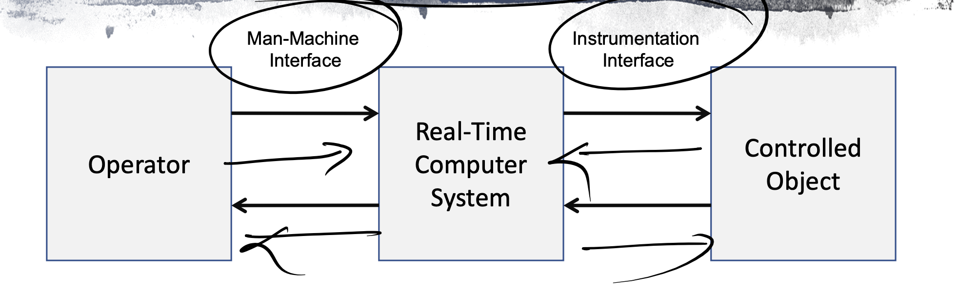

Certainly! Let's delve into the components and functions of Control Systems:

1. **Man-Machine Interface**:

- **Input Devices**: Input devices are interfaces that allow users to interact with the control system by providing input signals or commands. Common input devices include keyboards, mice, touchscreens, joysticks, buttons, switches, and voice recognition systems. Users use these input devices to provide commands or set parameters for the control system.

- **Output Devices**: Output devices are interfaces through which the control system communicates information or feedback to the user. Common output devices include displays (such as monitors or touchscreens), indicators (such as LEDs or LCDs), speakers, alarms, and haptic feedback devices. These devices provide users with feedback on the status, performance, or output of the control system.

2. **Instrumentation Interface**:

- **Sensors**: Sensors are devices that detect and measure physical phenomena, such as temperature, pressure, position, motion, light, or sound, and convert them into electrical signals or digital data. Sensors play a crucial role in providing feedback to the control system about the current state or condition of the system or environment being controlled. Examples of sensors include temperature sensors, pressure sensors, proximity sensors, accelerometers, gyroscopes, and cameras.

- **Actuators**: Actuators are devices that receive commands from the control system and convert them into physical actions or movements. Actuators manipulate the system or environment being controlled based on the commands received from the control system. Examples of actuators include motors, solenoids, valves, pumps, heaters, fans, and relays. Actuators are responsible for implementing control actions to achieve the desired state or behavior of the system.

In summary, the Man-Machine Interface and Instrumentation Interface are essential components of control systems that enable interaction between users and the system and facilitate the monitoring and control of physical processes or systems. Input devices allow users to provide commands or inputs to the control system, while output devices provide feedback or information to users. Sensors and actuators interface with the physical environment to measure and control variables, converting physical signals into digital data that the control system can process and act upon. Together, these interfaces enable the effective operation and control of various systems and processes in fields such as industrial automation, robotics, automotive, aerospace, and more.

of RTS

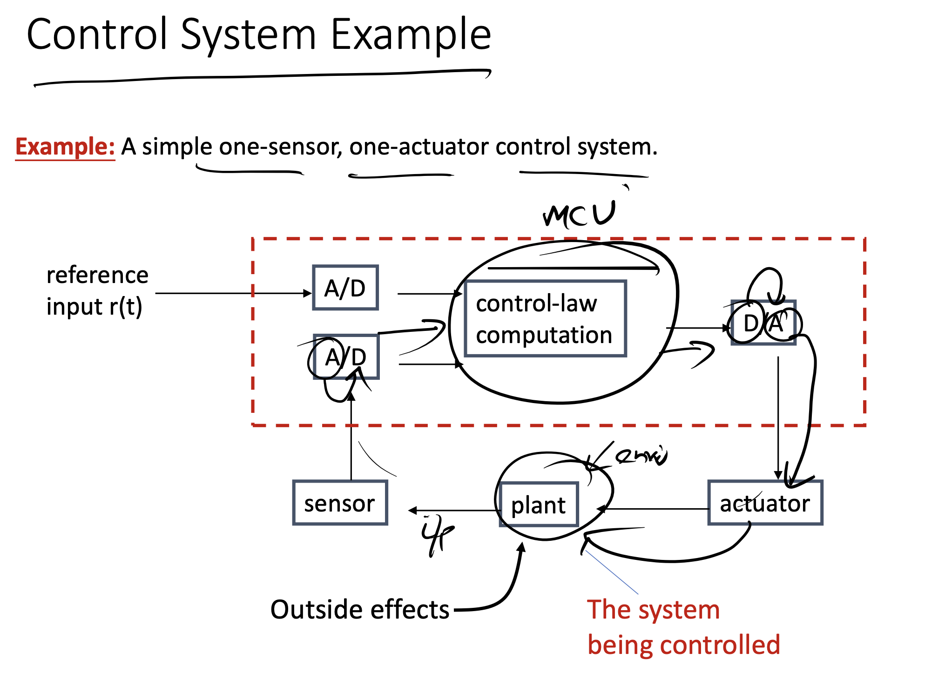

of RTS

**7 Design Principles**

Sure, let's break down each of these design principles with examples:

1. **Equitable Use**: This means making sure everyone can easily use and benefit from whatever you're designing. For example, imagine a library where all the bookshelves are at different heights. Some people might struggle to reach the books on the higher shelves, so it's not equitable. But if the shelves are all at a reachable height for everyone, it's equitable.

2. **Flexibility in Use**: This principle is about giving people options. For instance, think about a smartphone. It's designed so you can use it in different ways: tapping, swiping, or even using voice commands. This flexibility makes it easier for different people to use it in the way that works best for them.

3. **Simplicity and Intuitiveness of Use**: Basically, this means making things easy to understand and use. Think about a traffic light. You see red, you know to stop; green means go. It's simple and intuitive, no matter what language you speak or how much you know about traffic rules.

4. **Perceptible Information**: This is about making sure people can easily notice and understand the information you're giving them. Consider a crosswalk with both lights and sound signals for when it's safe to cross. This helps people who might have trouble seeing or hearing, making the information perceptible in different ways.

5. **Tolerance for Error**: Mistakes happen, but good design can minimize their impact. For example, think about a microwave with a timer. If you accidentally set it for too long, it's helpful if there's an easy way to stop it before your food burns. That way, your mistake doesn't ruin your meal.

6. **Low Physical Effort**: Design should be comfortable and not make people tired. Imagine a door with a handle that's hard to turn. It might be difficult for someone with arthritis to open. But if the door has a lever instead of a knob, it's easier for everyone to open, regardless of physical ability.

7. **Size and Space for Approach and Use**: This is about making sure your design is accessible to everyone. For instance, a public restroom might have stalls that are large enough for a wheelchair to fit into comfortably. This ensures that everyone, regardless of physical ability, can use the restroom safely and comfortably.

**Current Incarcations-**

1. **Specialized Hardware**:

- In current incarnations, specialized hardware refers to devices or equipment designed for specific purposes or applications. This hardware is often optimized to perform particular tasks efficiently and may include components tailored to the intended function.

- Examples of specialized hardware in current incarnations include smart thermostats for home climate control, smart doorbell cameras for home security, and wearable fitness trackers for personal health monitoring.

2. **Domestic Setting**:

- Current incarnations of technology are commonly found in domestic settings, meaning they are used within households or residential environments. These technologies are integrated into everyday life to enhance comfort, convenience, safety, and entertainment for individuals and families.

- Examples of technologies in the domestic setting include smart appliances (e.g., refrigerators, washing machines), home automation systems (e.g., smart lighting, smart locks), and entertainment devices (e.g., smart TVs, streaming media players).

3. **Initially Aimed at Home Automation**:

- Initially, many of these technologies were developed with a focus on home automation, which involves the integration of technology and systems to control various aspects of a home environment automatically.

- Home automation systems allow users to remotely monitor and manage household devices and systems, such as heating and cooling, lighting, security cameras, and door locks, using smartphones or other smart devices.

4. **Mostly Used for Home Entertainment**:

- While home automation was an initial focus, current incarnations of technology are predominantly used for home entertainment purposes. This includes devices and services designed to deliver audio, video, gaming, and other forms of entertainment to users within their homes.

- Examples of home entertainment technologies include smart TVs with streaming capabilities, streaming media players (e.g., Roku, Amazon Fire TV), gaming consoles (e.g., PlayStation, Xbox), and subscription-based streaming services (e.g., Netflix, Disney+).

5. **All Open to 3rd Parties**:

- Many current incarnations of technology platforms and ecosystems are open to third-party developers and partners, allowing them to create compatible applications, services, or add-ons that extend the functionality or interoperability of the existing technology.

- This openness encourages innovation and collaboration within the technology ecosystem, leading to a wider range of features, services, and integrations for users.

- Examples of platforms open to third parties include smart home platforms like Amazon Alexa, Google Assistant, and Apple HomeKit, which allow developers to create compatible smart home devices and voice-controlled applications.

In summary, current incarnations of technology feature specialized hardware designed for domestic settings, initially aimed at home automation but predominantly used for home entertainment purposes. These technologies are often open to third-party developers, fostering innovation and collaboration within the ecosystem.

The IoT architectural landscape

Certainly! Let's break down the key points about the IoT architectural landscape and explain them properly:

1. **Diverse Range of Applications**:

- The IoT (Internet of Things) landscape encompasses thousands of new applications across various domains or verticals. These applications range from smart homes, healthcare, agriculture, transportation, industrial automation, to environmental monitoring, and more.

2. **Unique Application Requirements**:

- Each IoT application has its unique set of requirements, including data volume, latency, security, reliability, scalability, and interoperability. As a result, IoT systems tend to be complex, with customized solutions tailored to specific use cases.

3. **Complexity and Proprietary Solutions**:

- Combining multiple IoT applications often leads to complex systems that are challenging to manage. Moreover, many IoT solutions are proprietary, making it difficult to integrate them with other systems and platforms.

4. **Challenges in Unified Architecture**:

- Defining a unified architecture for IoT is challenging due to the diversity of applications and their unique requirements. A proliferation of standards can exacerbate interoperability problems, making it difficult for different IoT devices and systems to communicate effectively.

5. **Efforts to Define Common Frameworks**:

- Various entities, including international standardization bodies, collaborative research projects, industry consortiums, and large commercial actors, are working to define common frameworks and standards for IoT. These efforts aim to establish interoperability and facilitate seamless integration of IoT solutions.

6. **Documentation Challenges**:

- Despite efforts to define common standards, device and protocol documentation in the IoT space is often scattered and fragmented. Navigating through this documentation can be challenging for developers, hindering the adoption and implementation of IoT solutions.

7. **Focus on Key Principles and Architectural Patterns**:

- To address the complexity and challenges in the IoT landscape, it's essential to focus on the key principles and architectural patterns that underpin successful IoT deployments. By identifying common principles shared across different IoT architectures, stakeholders can better understand and navigate the IoT ecosystem.

In summary, the IoT architectural landscape is characterized by diversity, complexity, and ongoing efforts to establish interoperability and standardization. Despite challenges, focusing on key principles and collaborative efforts can help address the complexities and drive innovation in the IoT space.

Key considerations for IoT architectures

Sure, let's break down the key considerations for IoT architectures in easy language with examples:

1. **Application Domains Coverage**:

- Consider which areas or domains your IoT solution will be used in. This could include smart homes, healthcare, agriculture, transportation, industrial automation, environmental monitoring, and more. For example, a smart home IoT system might include devices like smart thermostats, security cameras, and lighting controls.

2. **Placement of Intelligence**:

- Decide where to place the "intelligence" in your IoT system. This could be on the devices themselves (edge computing), in a centralized cloud server, or distributed across multiple layers. For instance, in a smart manufacturing environment, edge devices embedded with AI algorithms can analyze data in real-time to optimize production processes without relying heavily on cloud connectivity.

3. **Networking Structure**:

- Choose the networking structure that best suits your IoT application's requirements. This could involve using protocols like Wi-Fi, Bluetooth, Zigbee, LoRaWAN, or cellular networks depending on factors such as range, data rate, power consumption, and deployment environment. For example, a smart agriculture system might utilize LoRaWAN for long-range communication between sensors spread across a wide field.

4. **Modularization for Complexity Management**:

- Modularize your IoT system to manage complexity and enable programmability. Break down the system into smaller, interchangeable modules or components that can be developed, tested, and maintained independently. This allows for easier scalability and flexibility in adding or updating functionalities. An example could be a modular smart city platform where different modules handle transportation management, waste management, and energy optimization, allowing cities to customize and scale their IoT solutions according to their needs.

5. **Cost and Scalability Implications**:

- Consider the cost and scalability implications of your IoT architecture. Evaluate factors such as hardware costs, maintenance expenses, data storage and processing fees, and the ability to scale the system as the number of connected devices grows. For instance, deploying a large-scale smart grid infrastructure may require significant upfront investment in hardware and infrastructure, but it can lead to long-term cost savings and scalability benefits through optimized energy management.

By carefully considering these key aspects, you can design an effective and efficient IoT architecture that meets the specific needs of your application while ensuring scalability, flexibility, and cost-effectiveness.

Cloud vs. Fog vs. Edge

Certainly! Let's break down the differences between Cloud, Fog, and Edge computing in the context of networked systems like IoT:

1. **Cloud Computing**:

- **Overview**: Traditionally, cloud computing has dominated the networked systems landscape. In cloud computing, all intelligence resides on powerful remote servers, often located in data centers. These servers handle tasks such as data storage, processing, analytics, and hosting of web interfaces.

- **Role of End Devices**: End devices in cloud computing act primarily as information gatherers, collecting data from sensors or devices in the field and transmitting it to the cloud for processing and analysis.

- **Scaling Challenges**: While cloud computing offers scalability and centralized management, it may face challenges as the number of IoT devices grows and applications diversify, leading to increased data generation and processing demands. The reliance on centralized servers can introduce latency and bandwidth issues, especially in applications requiring real-time responsiveness.

2. **Fog Computing**:

- **Overview**: Fog computing extends the cloud paradigm by bringing computing resources closer to the edge of the network, typically at the network's edge devices or local data centers. It aims to address latency and bandwidth constraints by processing data closer to where it is generated.

- **Role of End Devices**: In fog computing, end devices play a more active role in processing and analyzing data locally before transmitting relevant information to the cloud. This reduces the amount of data sent to the cloud and enables faster response times for critical applications.

- **Scalability and Efficiency**: Fog computing enhances scalability and efficiency by distributing computing tasks across a hierarchical network architecture, leveraging both edge and cloud resources. It is well-suited for applications requiring low-latency processing, real-time analytics, and distributed decision-making.

3. **Edge Computing**:

- **Overview**: Edge computing pushes computing resources even closer to the end devices, directly at the network's edge. It involves deploying computing and storage capabilities directly within IoT devices or on nearby gateway devices.

- **Role of End Devices**: End devices in edge computing actively participate in data processing, analysis, and decision-making. They handle tasks such as filtering, aggregation, and pre-processing of data before sending only relevant information to higher-level systems.

- **Real-time Responsiveness**: Edge computing offers ultra-low latency and high-speed data processing, making it ideal for applications requiring real-time responsiveness, such as autonomous vehicles, industrial automation, and remote monitoring systems.

- **Scalability Challenges**: While edge computing offers superior performance and responsiveness, it may face challenges in scalability due to limited resources and distributed management. However, advancements in edge computing technologies, such as edge AI and edge cloud integration, are addressing these scalability concerns.

In summary, while cloud computing remains dominant for certain applications, fog and edge computing offer compelling alternatives, especially for IoT deployments requiring low latency, real-time analytics, and efficient use of network resources. Each approach has its advantages and is best suited for specific use cases depending on factors such as latency requirements, data volume, and scalability needs.

Characteristics

of Characteristics

of RTS

Characteristics

of

Security challenges

Certainly! Let's break down each security measure in easy language:

1. **Hardware Isolation (Arm TrustZone)**:

- Arm TrustZone is a technology that provides hardware-based isolation between secure and non-secure components within a device's processor. It creates a secure environment (TrustZone) within the processor where sensitive operations can be executed safely without interference from other parts of the system.

2. **Middleware (Speculative Store Bypass Barrier – SSBB)**:

- The Speculative Store Bypass Barrier (SSBB) is a security feature implemented in middleware, which is software that acts as a bridge between the operating system and applications. SSBB helps prevent speculative execution attacks by creating a barrier between speculative memory accesses and sensitive data.

3. **Network Isolation (Software-defined Networking – SDN)**:

- Software-defined Networking (SDN) is a networking approach that allows network administrators to programmatically control network behavior through software applications. SDN can help improve security by creating virtual networks with isolated communication channels, making it harder for attackers to move laterally within a network.

4. **Data Confidentiality in Transit (Transport Layer Security – TLS)**:

- Transport Layer Security (TLS) is a cryptographic protocol used to secure communication over a network, such as the internet. TLS encrypts data transmitted between a client (such as a web browser) and a server (such as a website), ensuring that it remains confidential and cannot be intercepted or tampered with by attackers.

5. **Software Isolation (Containers)**:

- Containers are a lightweight form of virtualization that encapsulate applications and their dependencies, allowing them to run in isolated environments. Containers help improve security by sandboxing applications, preventing them from accessing resources or data outside of their designated environment.

In summary, to secure the entire ecosystem from hardware to application, various security measures can be implemented:

- Arm TrustZone provides hardware-based isolation within processors.

- Middleware features like SSBB prevent speculative execution attacks.

- SDN enables network isolation through programmable control.

- TLS ensures data confidentiality in transit over networks.

- Containers offer software isolation by encapsulating applications in isolated environments.